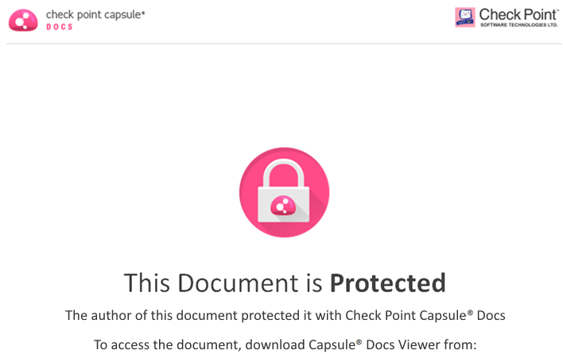

<http://CapsuleDocs.com>